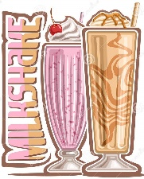

**Salted Caramel**

**Smoothies**

**Mocktails**

**Freezos**

**Chocolate**

**Waffles Bites**

**Ice creams**

**Milkshakes**

**Shake Shoppe**